[DCO-2447] Motive Financial - Activation Screen Landing page contains multiple h1 headings Created: 30/Apr/24 Updated: 06/May/24
Status: | In External Review
Project: | Journey Manager
Components: | None
Affects versions: | None
Fix versions: | Accessibility

Type: | Story | Priority: | None
Reporter: | Sanya Khandhuja | Assignee: | Fusi Olateru
Resolution: | Unresolved | Votes: | 0
Labels: | Motive, MotiveAuthenticated
Remaining Estimate: | Not Specified
Time Spent: | Not Specified
Original estimate: | Not Specified

Attachments: | image-20240430-180124.png image-20240430-180145.png image-20240430-180210.png
QA Bug Count: | 0
Days Open: | 6 days
Bug Count: | 0
Hours Variance: | 0
Hours Remaining: | 0
Hours Target PMO: | 0
Sprint:
Days Open: | 6

Description

The landing page to activate your account contains multiple <h1> headings.
Examples:

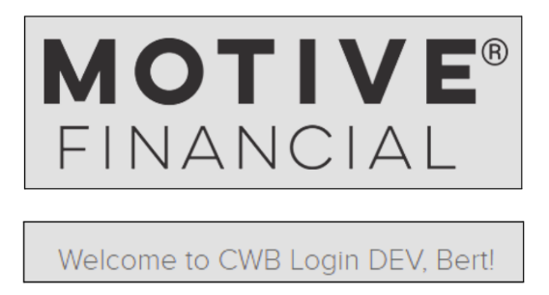
■ Recommendation: Ensure that the page has one and only one <h1> heading, being the main heading of the page.

Comments

Comment by Fusi Olateru [ 03/May/24 ]
We cannot modify this. It goes away with OIE
Comment by Ian Hicks [ 06/May/24 ]
*Note: “*preview sandbox” banner element is not relevant as this would not be present on a PROD environment.
Generated at Mon May 06 21:47:58 UTC 2024 by Ian Hicks using Jira 1001.0.0-SNAPSHOT#100252-rev:aa264b414382dcd2bbea0c3e63c78e358e7de0d5.

